Sanxingdui VR Exhibition (Cultural Space Experience) with LLM Q&A System

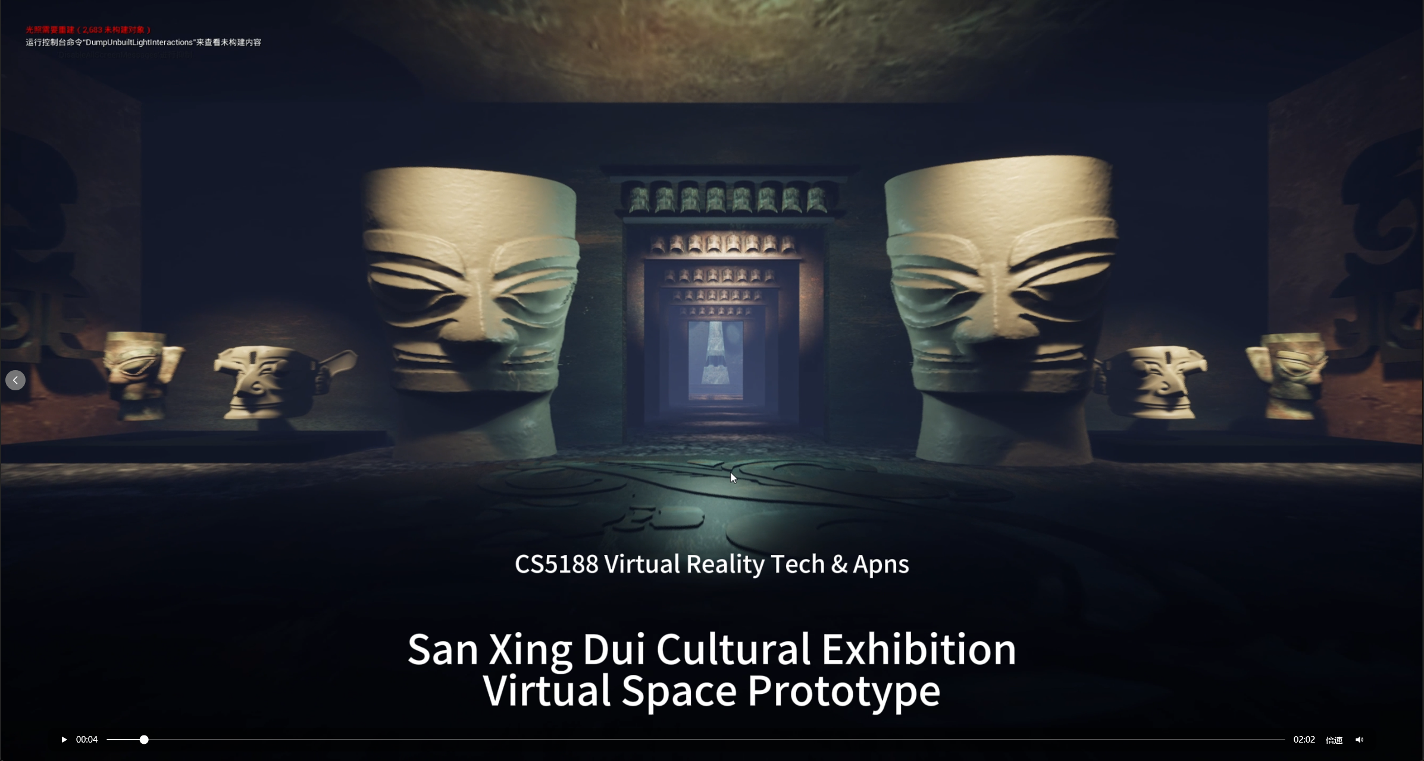

Group members：

Li Mingxi 60025077：All 3D modeling and asset preparation; scene switching between narrative spaces; audio: ambient tracks and transition sound effects before entering the sacred-tree segment. Drafting or revising sections on art pipeline, level flow, Exhibition Curatorial planning.

Pei Yuxin 59628021：Embedding the AI Q&A module into the interactive experience (UI / WebView or project-specific bridge as implemented); other interaction behaviors (inputs, UI flow).

Chen Xian 59790558：Implementation of the AI module: backend/services, knowledge-base and chat-related logic, configuration and integration support for the intelligent Q&A pipeline. Drafting or revising sections on the AI subsystem, advanced features, and technical effort.

Completed Basical Tasks：
(1) Creating a new object
All exhibit-related objects in the experience were newly created or newly imported and placed for this project: for example, environment pieces and focal artifacts associated with the Sanxingdui theme (including the “bronze grand mask” and related props), assembled into Unreal levels after modeling and/or simplified import (Datasmith / interchange workflow as used in the pipeline). Materials and transforms were set so objects read clearly in first-person exploration.
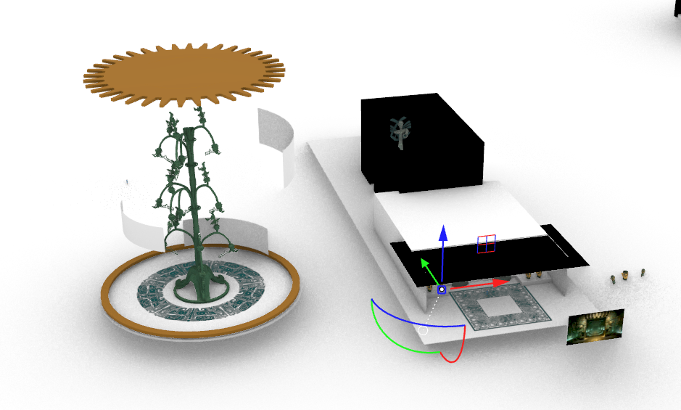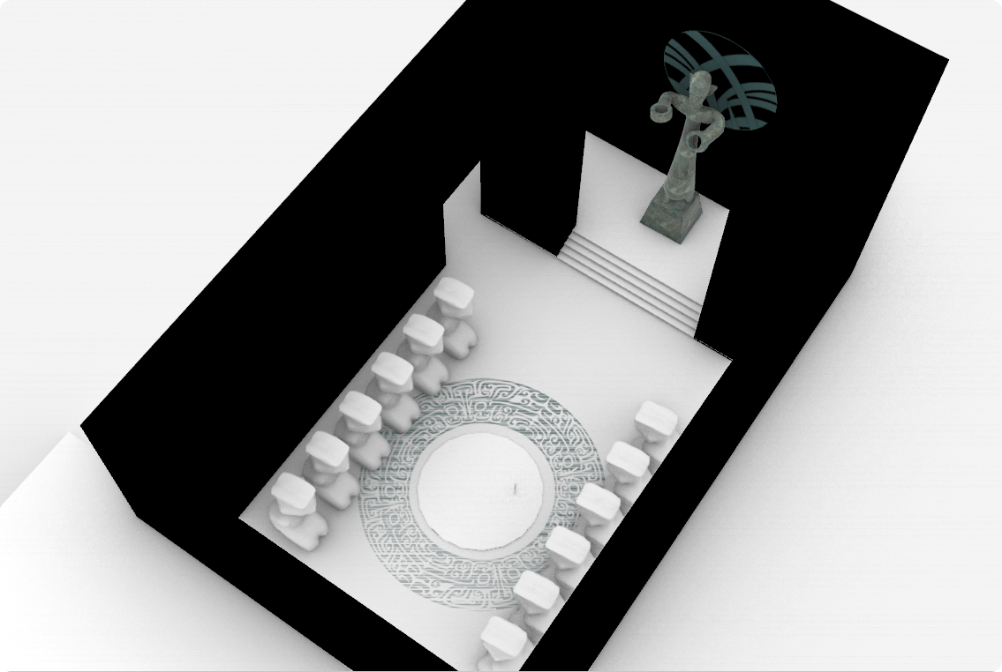
(Model Building in Rhino 8, Original File is too large so screenshots here presents work.)
(Many efforts paid here.)

(2) Object manipulation
We bound keyboard left / right (e.g., arrow keys or equivalent) to yaw rotation of the bronze mask actor (Blueprint or input mapping in the First Person project). Rotation is applied smoothly within sensible limits so the mask remains readable and does not clip through the environment.
While viewing the mask, the player can “rotate it left and right“ to inspect details from different angles, supporting the educational / museum style of the application.
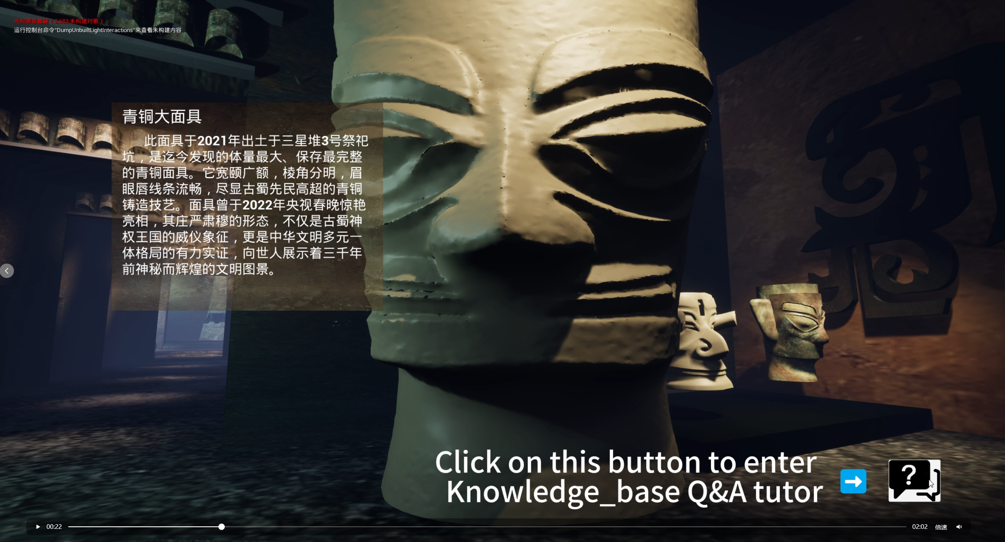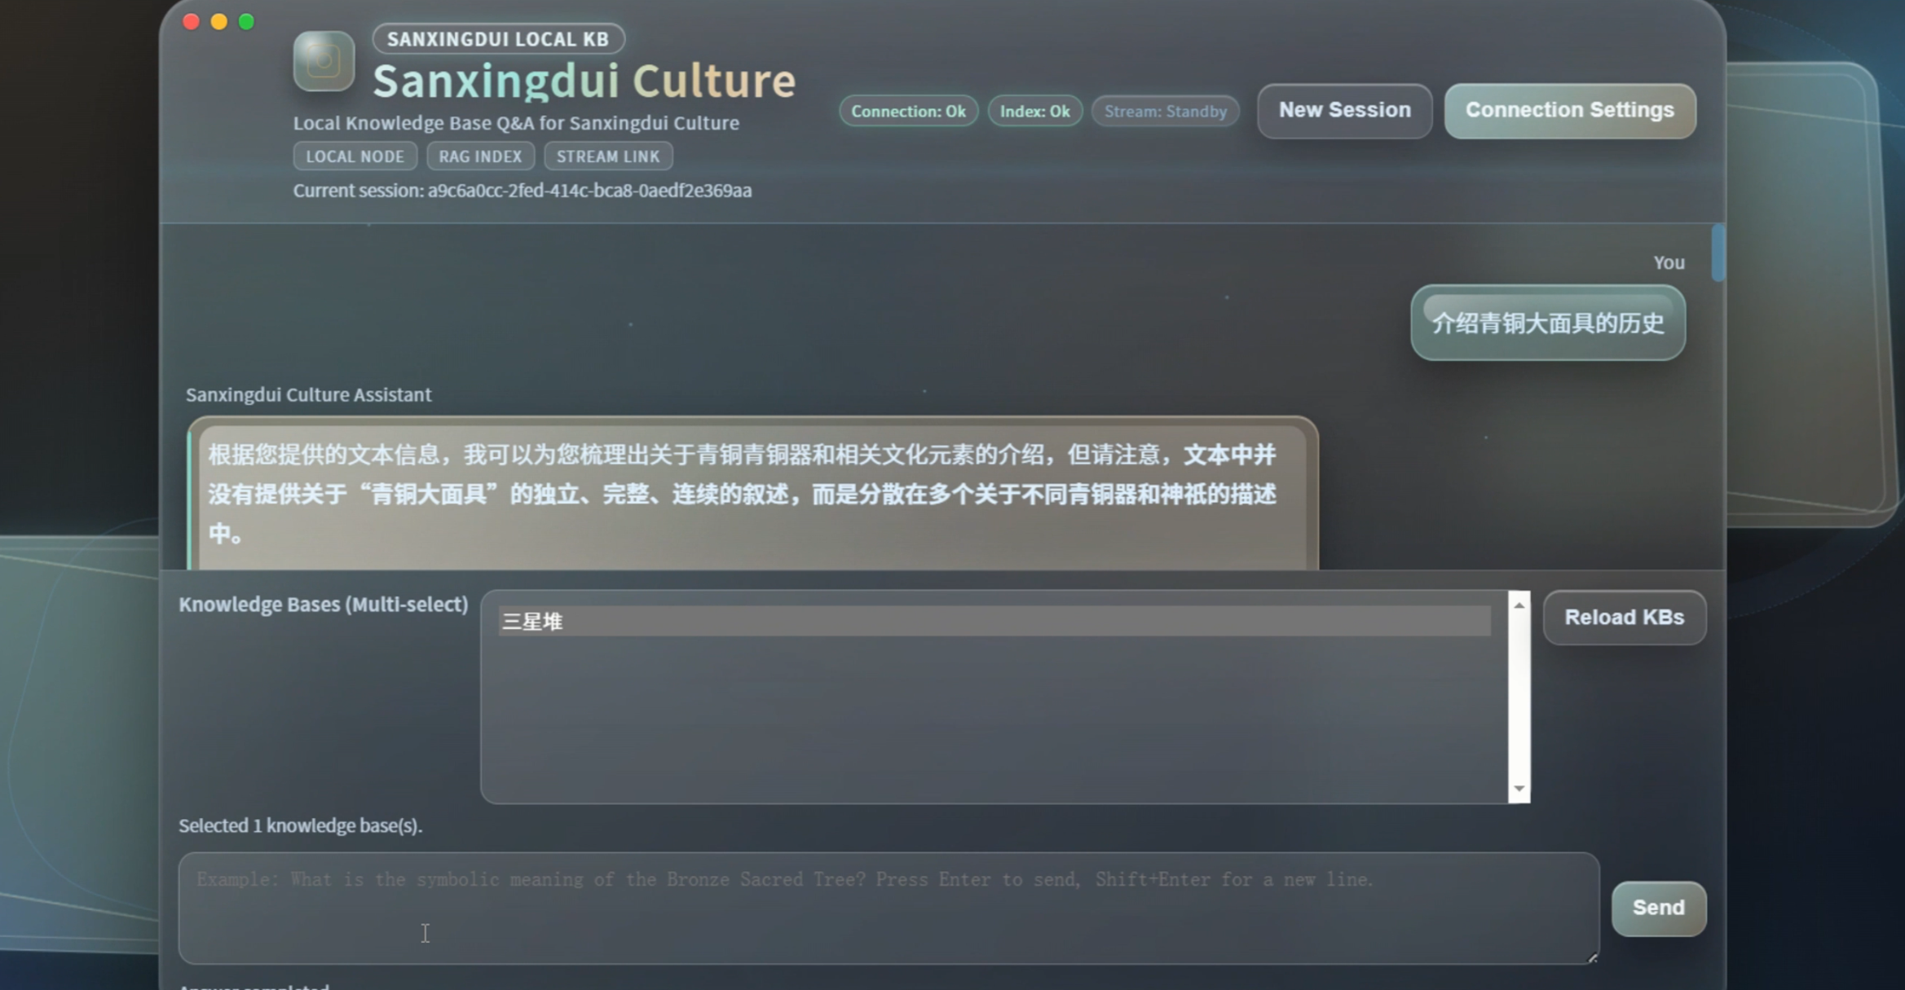

(3) Audio ambience
We added one-shot or short transitional SFX triggered during the transition into the sacred tree scene, so the change of space is audible as well as visible. Audio settings follow the project’s 48 kHz configuration in `DefaultEngine.ini`.

Players hear a clear acoustic cue that foreshadows or accompanies the move into the sacred-tree environment, improving immersion and narrative pacing.

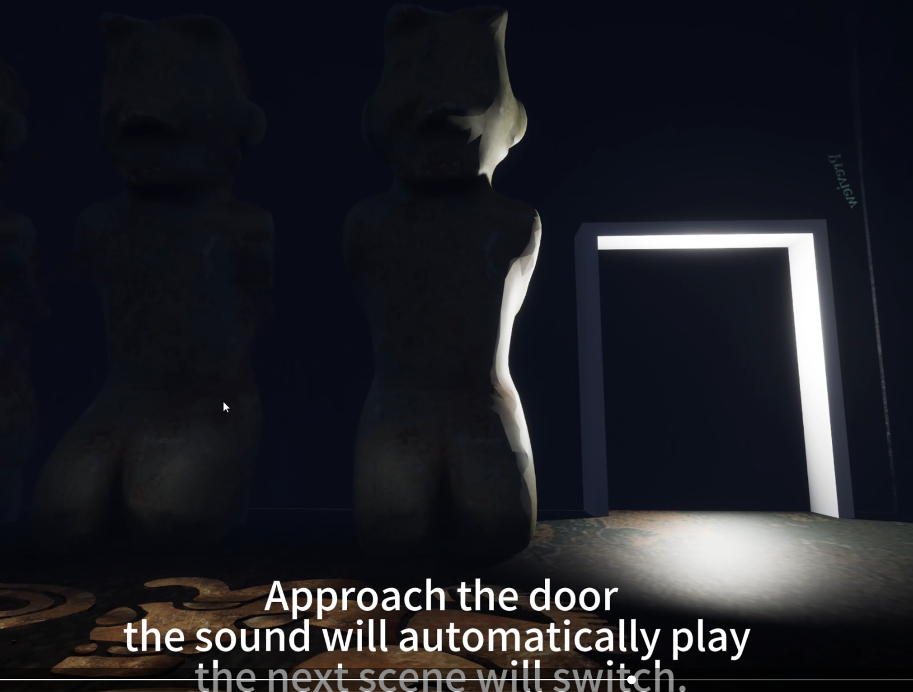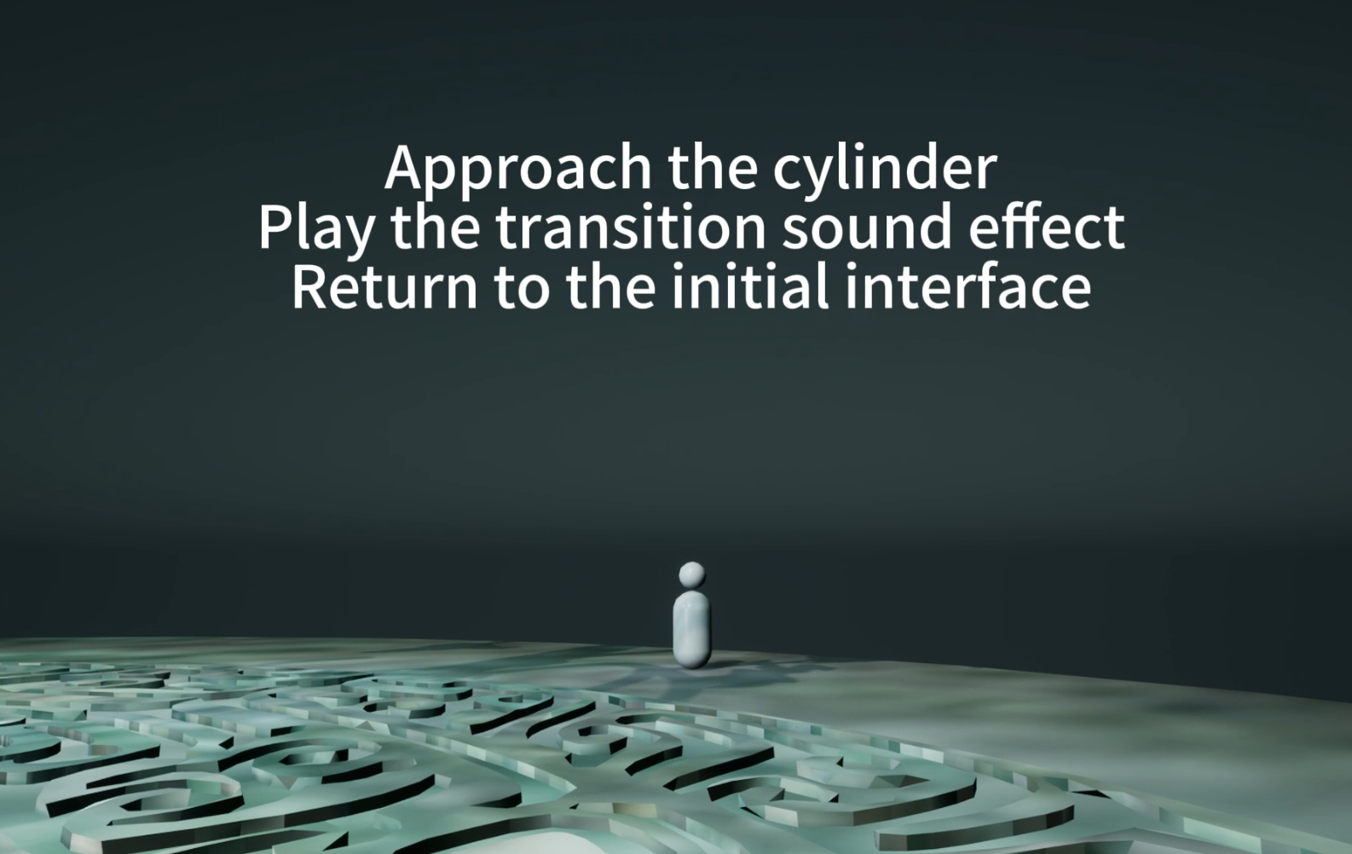
(Two Key Blueprint Component With title of BP_** in the project . In “Action” Document)

Application Description
The project is an Unreal Engine 5.7 first-person experience themed around 三星堆culture. It combines walk-able 3D spaces, inspected artifacts (including keyboard manipulation of the bronze mask), scene transitions between areas such as the sacred tree, and spatial audio. Alongside the game project, an AI module provides knowledge-base-backed Q&A and chat-style interfaces. Pei integrated this capability into the interactive product so visitors can ask questions about exhibits in a guided way, while Li developed the underlying intelligent module.

Related Works
[ Prototype Screenshot ]
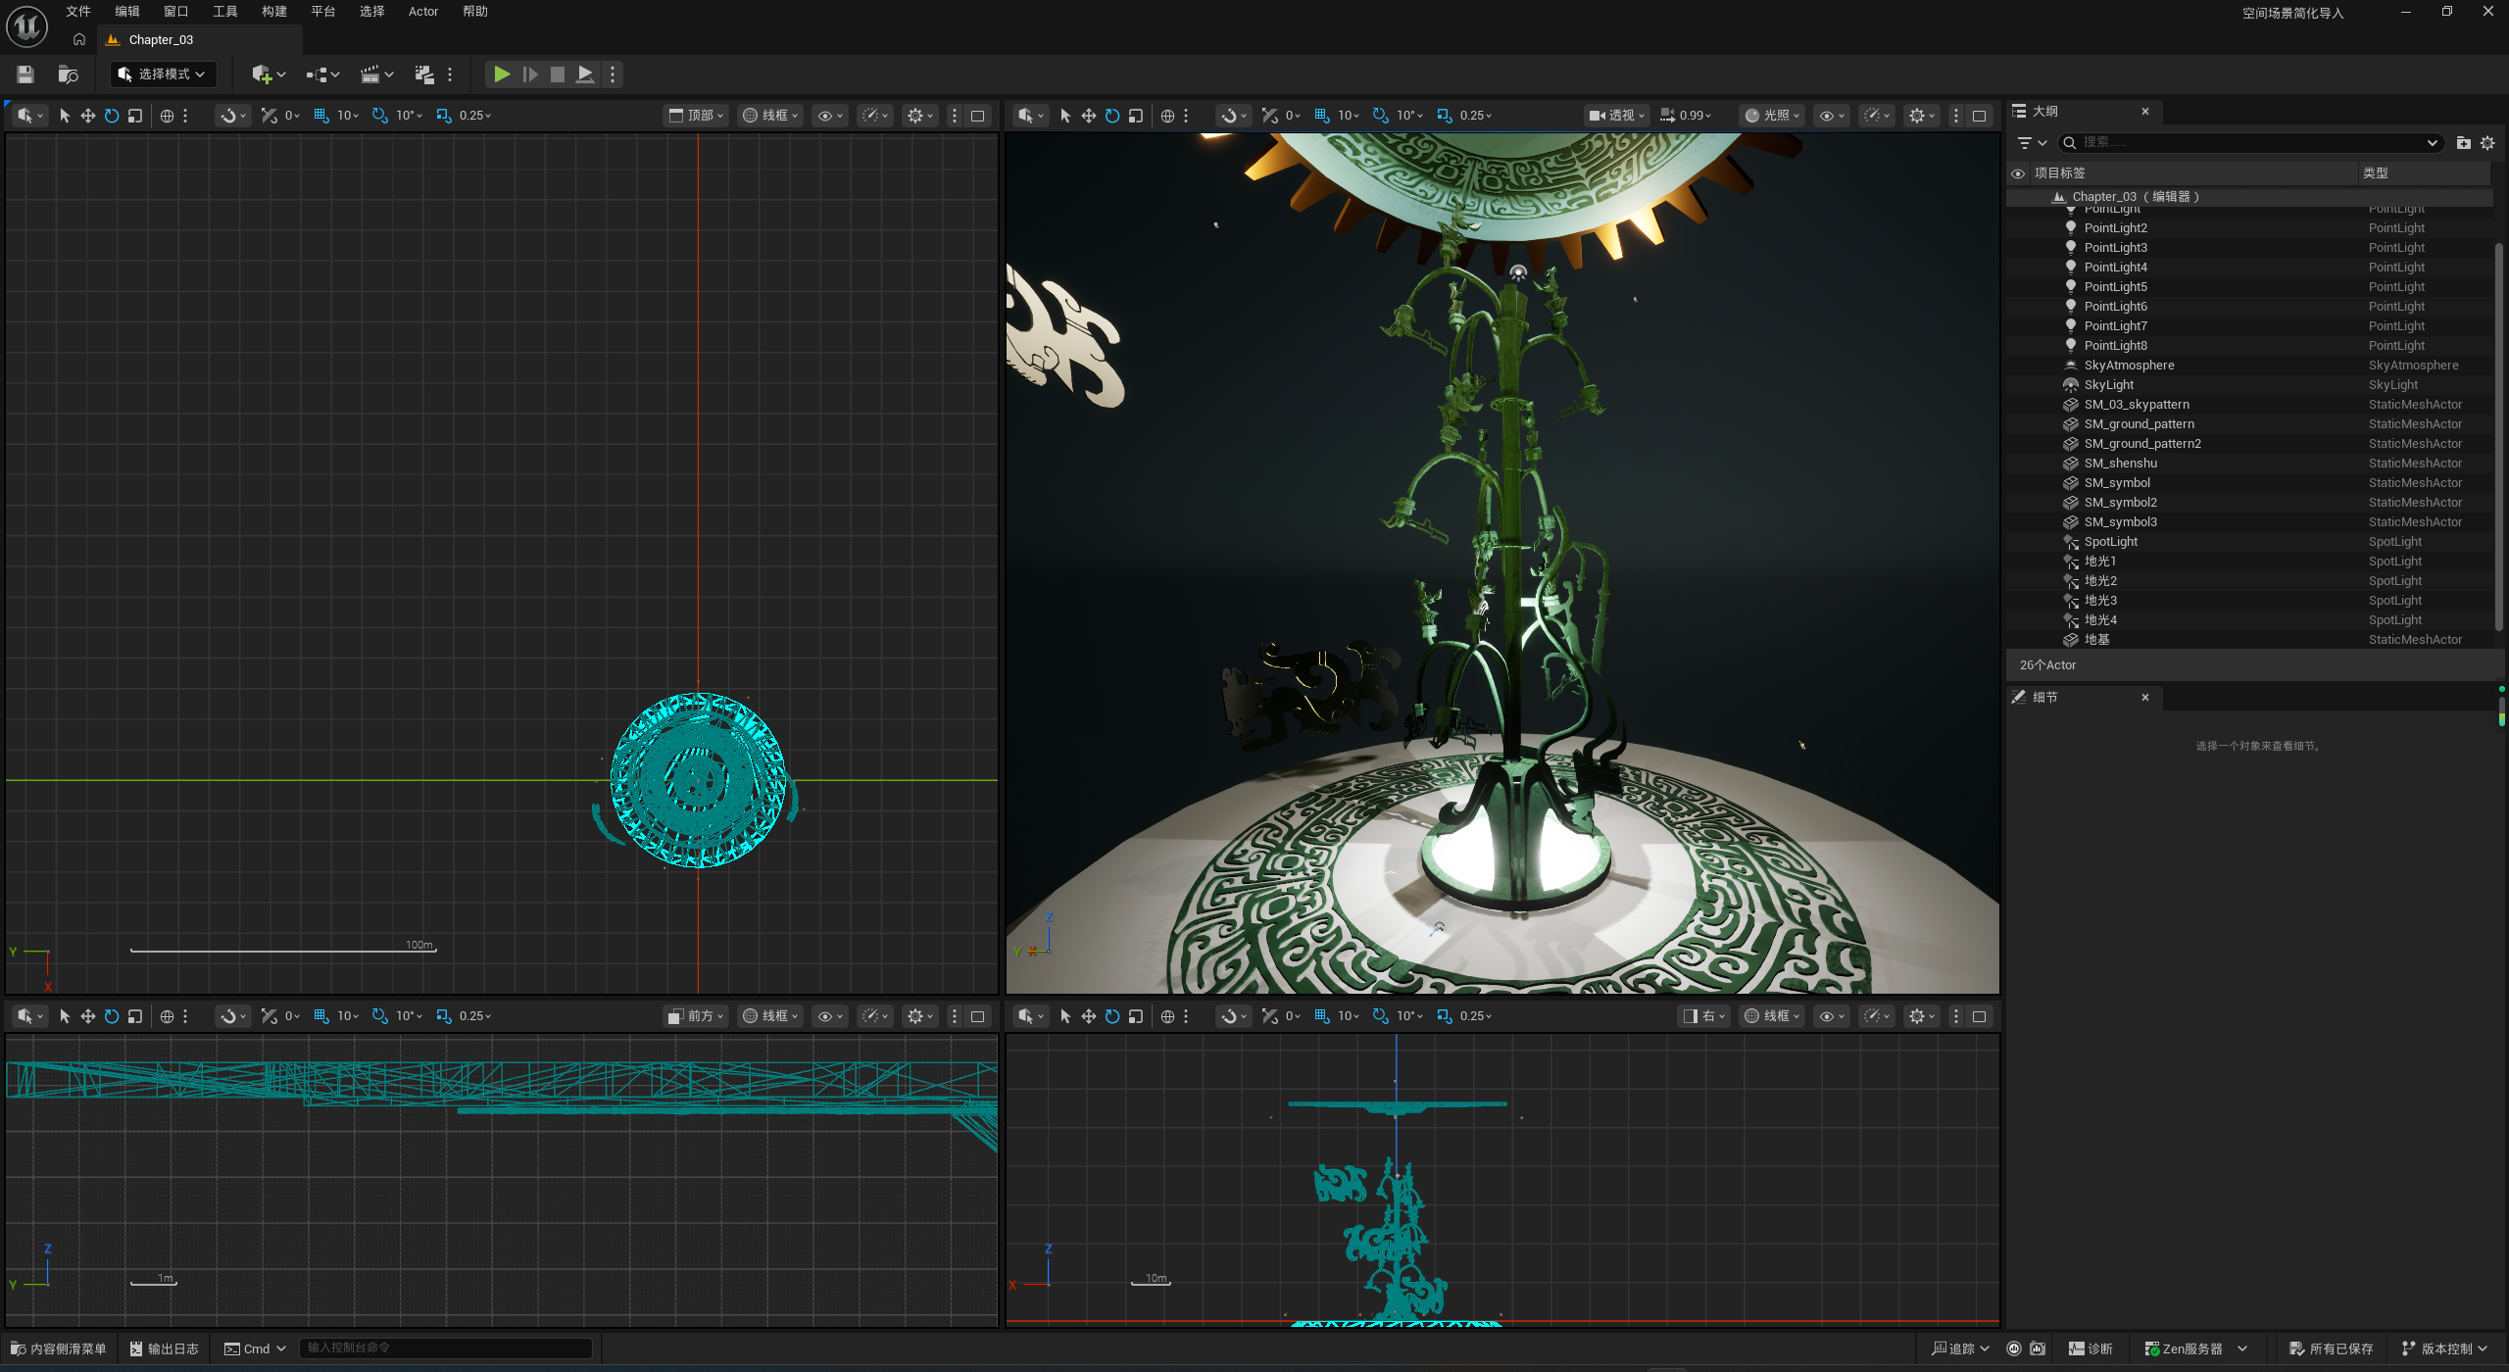
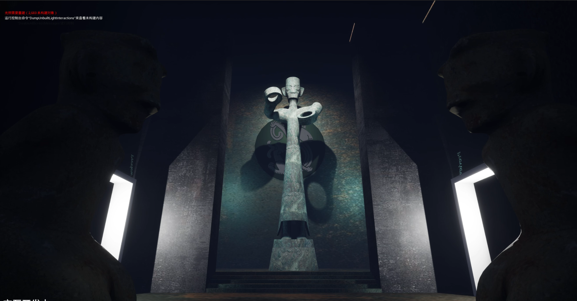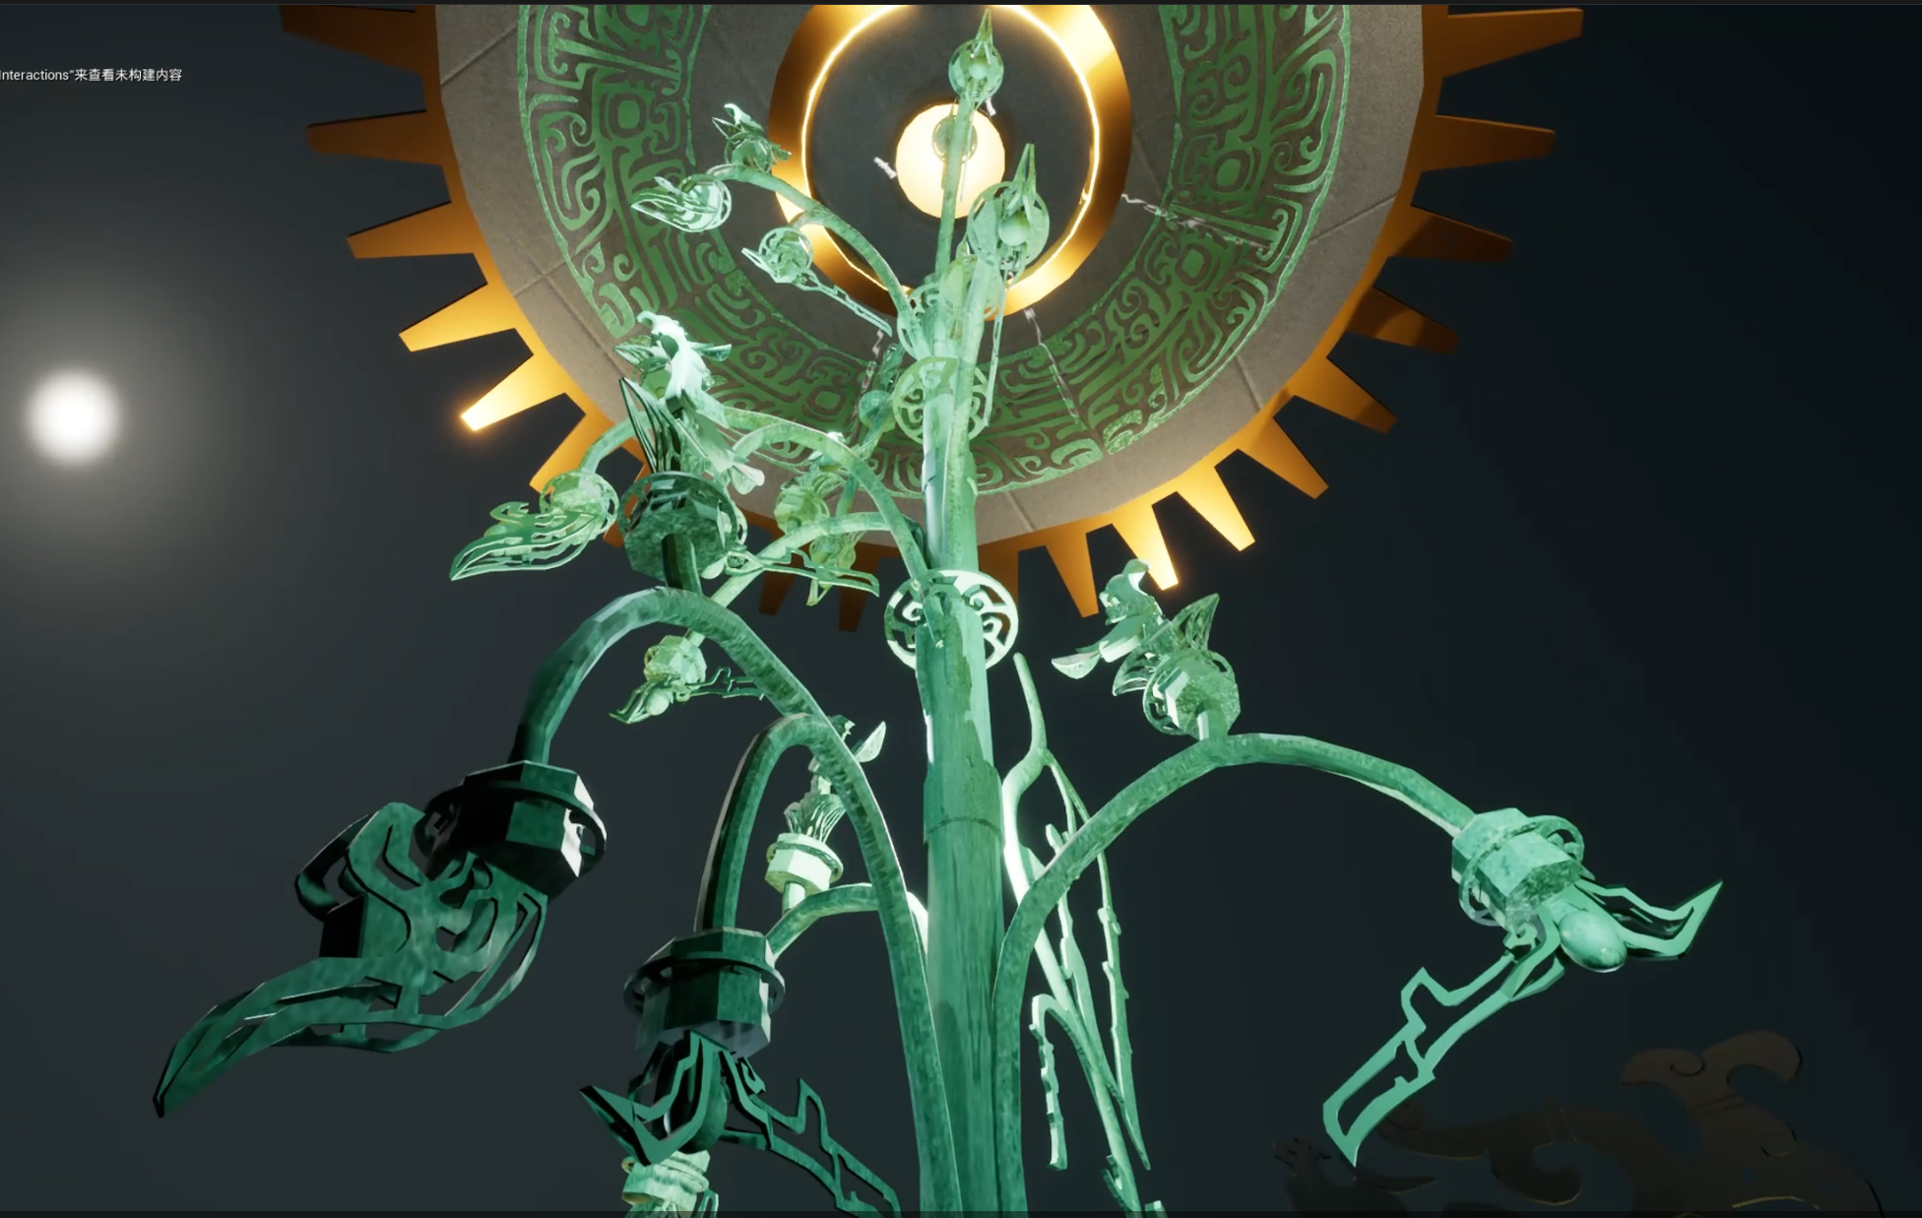

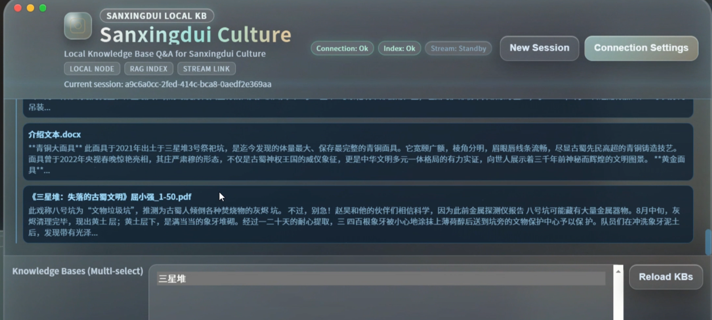
( The system implements a locally deployed RAG (Retrieval-Augmented Generation) framework optimized for high-precision knowledge discovery. It utilizes Qwen3-Embedding-4B for efficient vector indexing and Qwen3-Reranker-8B for deep semantic re-ranking to ensure the delivery of highly relevant contexts. Gemma 4 serves as the core conversational engine, performing logical reasoning and response generation based on the refined knowledge segments. By integrating this 'two-stage retrieval + robust reasoning' pipeline, the system effectively mitigates retrieval inaccuracies and factual hallucinations, providing a reliable and secure local QA solution.)
Left: Answers based on Knowledge base；Right: Knowledge base resource ( Proves )

[ Works Behind the Prototype ]
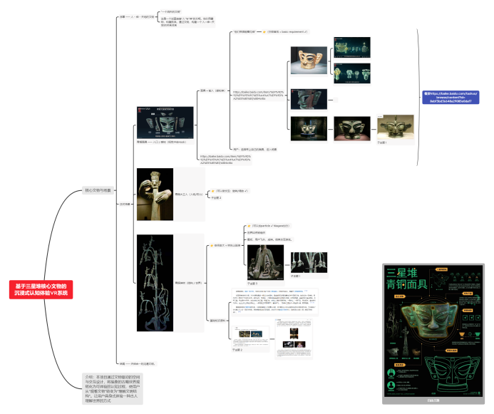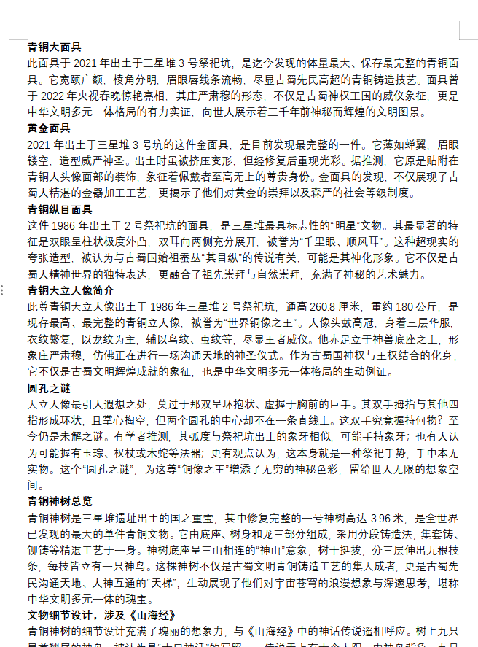
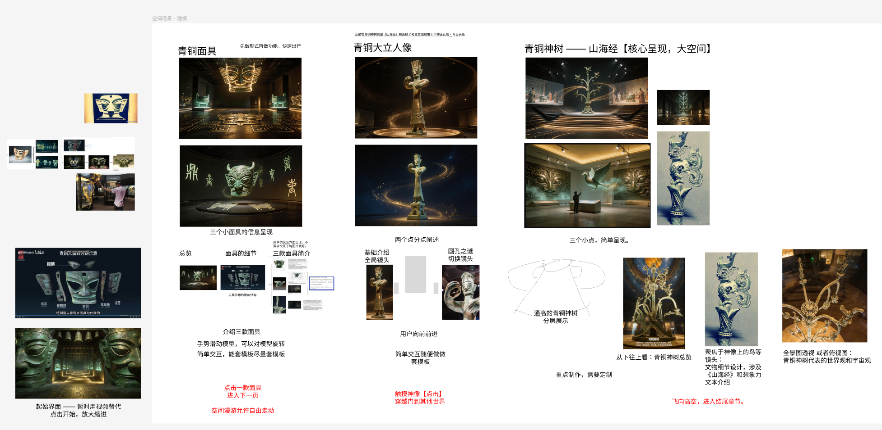
（The relevant exhibition outline and cultural corpus reserves）

Significance
The application serves as a prototype for a virtual exhibition, offering exploration with optional AI-guided explanation. It demonstrates coursework that integrates both real-time 3D environments and large language model/knowledge-base functionality.

Key features include:
- A knowledge-grounded museum guide: answers are based on a curated Sanxingdui knowledge base, reducing hallucinations and aligning the AI with curatorial intent.

- A cross-modal narrative: spatial transition audio paired with scene changes enhances the sense of entering a sacred space before the sacred tree becomes visible.
- Future development: VR controller interaction with the mask, localized Chinese/English switching in the AI panel, and lip-sync or narrator audio synchronized with AI responses.

